|  |  |
| --- | --- |
| Juiceshop Walkthrough Diploma in CSF  Year 3 Apr 2022 (Semester 5) | Week 2 |
| Practical |
| Forged Signed JWT | |

**OBJECTIVES**

* To perform cryptographic identification and analysis on sensitive information
* OWASP vulnerabilities: Sensitive Data Exposure and Cryptographic Failures (A03:2017, A02:2021)

**Challenge – Forged Signed JWT**

* To forge an almost properly RSA-signed JWT token that impersonates the (non-existing) under rsa_lord@juice-sh.op.
* Forged Signed JWT - Difficulty: 6/6 stars

**Step 1**

Launch Burpsuite and turn intercept off and sign into your account on Juiceshop.

**Step 2**

Locate this HTTP request that contains the JWT and send to repeater.

**Step 3**

Copy the JWT.

**Step 4**

Paste the JWT inside.

**Step 5**

Change the algorithm from ‘RS256’ to ‘HS256’ and the email from your own email to ‘rsa_lord@juice-sh.op’

**Step 6**

Locate the encryption files from Juiceshop by adding ‘encryptionkeys’ to the back of the home page URL.

**Step 7**

Click on the jwt file and save to your computer.

**Step 8**

Locate the file within your computer and open it with the ‘cat’ command to read its contents.

**Step 9**

Load <https://www.devglan.com/online-tools/hmac-sha256-online> and paste the entire content of the file into the secret key box. Copy the front section of the JWT into the plain text box as well.

**Step 10**

Select Base64 and compute the hash.

**Step 11**

Load <https://simplycalc.com/base64url-encode.php> and input the computed hash.

**Step 12**

Replace the part after the full stop with the result as seen below.

**Step 13**

Copy the newly formed JWT and paste it into the bearer and token section in burpsuite and click send and the challenge should be completed.

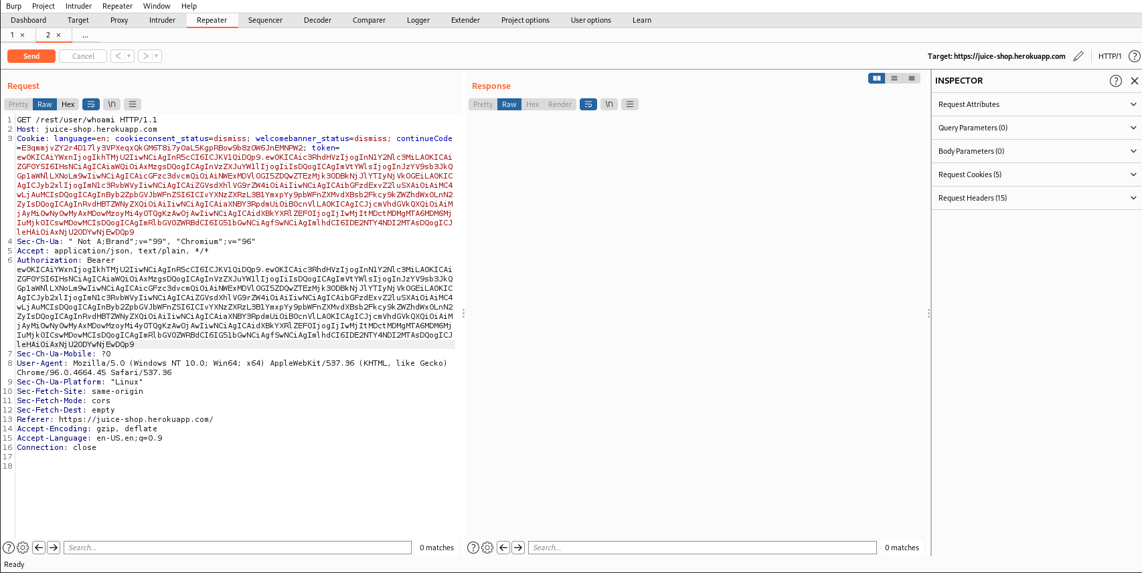

**~ End of Challenge ~**